HOW TO: Scanner Calibration | Version: 1.0.0
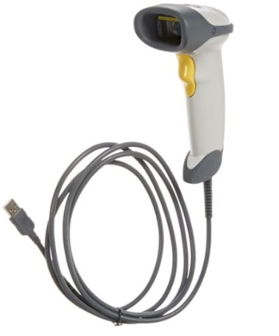  Printer Name: Scanner | Scanner Model: Symbol LS2208
Author: Yamija Munthali | Date Issued: 3rd November, 2017

Step 1:
Ensure that the Scanner is connected onto the usb port.

Step 2:
Wipe out the dirt on the scanner window with a wet tissue. | 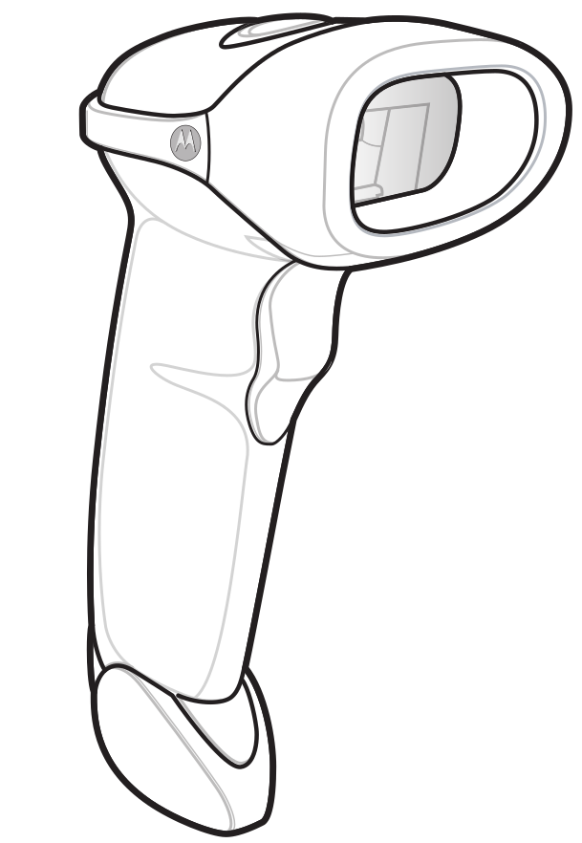  Scanner  window
Step 3:
Scan the configuration bar codes provided | 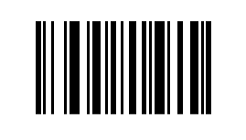  Set scanner to defaults
 | Set scan options
Set scanner to Data as it receives


Set the scanner to Send “$”
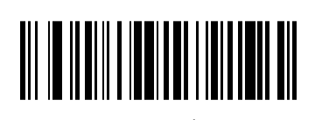

Save the Configurations
